- Copyright for test papers and marking guides remains with West Australian Test Papers.
- The papers may only be reproduced within the purchasing school according to the advertised conditions of sale.
- Test papers must be withdrawn after use and stored securely in the school until Friday 30 June 2017.

HUMAN BIOLOGY

Unit 1

2016


Name: _______________________________________________________

Teacher: ___________________________________________________

Time allowed for this paper

Reading time before commencing work: ten minutes
Working time for the paper: two hours and thirty minutes

Materials required/recommended for this paper
To be provided by the supervisor
This Question/Answer Booklet
Multiple Choice Answer Sheet

To be provided by the candidate:
Standard items: pens (blue/black preferred), pencils (including coloured), sharpener, correction fluid/tape, eraser, ruler, highlighters

Special items: non-programmable calculators approved for use in this examination.

Important note to candidates
No other items may be taken into the examination room. It is your responsibility to ensure that you do not have any unauthorised material. If you have any unauthorised material with you, hand it to the supervisor before reading any further.

Structure of this paper

Section | Number of questions available | Number of questions to be attempted | Suggested working time (minutes) | Marks available | Percentage of examination
Section One  Multiple-choice | 30 | All | 40 | 60 | 30
Section Two:  Short answers | 6 | All | 90 | 100 | 50
Section Three:  Extended answers | 2 | 1 | 20 | 40 | 20
 |  |  |  | Total | 100

Instructions to candidates

1. The rules for the conduct of the Western Australian Certificate of Education ATAR course examinations are detailed in the Year 12 Information Handbook 2017. Sitting this examination implies that you agree to abide by these rules.

2. Answer the questions according to the following instructions.

Section One: Answer all questions on the separate Multiple-choice answer sheet provided. For each question, shade the box to indicate your answer. Use only a blue or black pen to shade the boxes. If you make a mistake, place a cross through that square, then shade your new answer. Do not erase or use correction fluid/tape. Marks will not be deducted for incorrect answers. No marks will be given if more than one answer is completed for any question.

Section Two: Write your answers in this Question/Answer booklet. Wherever possible, confine your answers to the line spaces provided.

Section Three: Consists of two questions. You must answer one question. Identify the question you are answering.

3. You must be careful to confine your answers to the specific questions asked and to follow any instructions that are specific to a particular question.

4. Additional working space pages at the end of this Question/Answer booklet are for planning or continuing an answer. If you use these pages, indicate at the original answer, the page number it is planned/continued on and write the question number being planned/continued on the additional working space page.

Section One: Multiple-choice 30% (60 Marks)

This section has 30 questions. Answer all questions on the separate Multiple-choice Answer Sheet provided. For each question shade the box to indicate your answer. Use only a blue or black pen to shade the boxes. If you make a mistake, place a cross through that square, do not erase or use correction fluid, and shade your new answer. Marks will not be deducted for incorrect answers. No marks will be given if more than one answer is completed for any question.

Suggested working time: 40 minutes.

- Objectivity is a very important quality for a scientist. Which of the following best describes the difference between reliability and validity?

  - An experiment is valid if it tests what it is supposed to, whilst reliability is the extent to which an experiment produces the same result each time.
  - An experiment is reliable if it tests what it is supposed to, whilst validity is the extent to which an experiment produces the same result each time.
  - Validity can be improved by performing the experiment on a large number of subjects at the same time, whilst reliability can be improved by repeating the experiment with a new set of equipment.
  - Reliability is dependent on the number of uncontrolled variables, whilst validity is only dependent on the experimental variables.

Use the following data, which shows the list of resting pulse rates of ten Year 11 Human Biology class members, to answer Questions 2 to 4.

76 | 84 | 89 | 71 | 69 | 73 | 97 | 82 | 23 | 88

- The mean pulse rate for the class is calculated to be

  - 76
  - 75
  - 23
  - 73

- The 9th student recorded a pulse rate of 23. What is the name given to such results that appear to be ‘abnormal’?

  - Averages
  - Mistakes
  - Outliers
  - Trials

- Which of the following is the best way of presenting the data of the resting pulse rates?

  - Line graph
  - Bar graph
  - Histogram
  - Pie graph

- Cells are small because as the size of a cell increases, the

  - volume and surface area decrease.
  - surface area and volume increase at the same rate.
  - volume increases at a greater rate than the surface area.
  - surface area increases at a greater rate than volume.

- Cells with similar structure and function form

  - specialised cells.
  - tissues.
  - organs.
  - systems.

- Osmosis is best described as

  - the movement of both water and solutes from an area of low solute concentration to high concentration.
  - the movement of solutes from areas of high solute concentration to low solute concentration.
  - diffusion of water along the concentration gradient.
  - movement of water from an area of low solute concentration to high solute concentration.

- A microscope with a 10x ocular lens and 10x objective lens has a field of view of 2mm. What will the field of view be with a 4x objective lens?

  - 0.5mm
  - 2.5mm
  - 5mm
  - 6mm

Use the following diagram to answer Questions 9 to 11

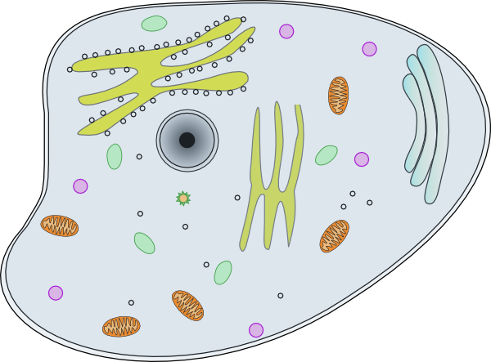
F
E
D
C
B
A

- Which letter indicates the site where biosynthesis, processing and transport of proteins can occur?

  - A
  - B
  - C
  - D

- What are the outputs of organelle B when oxygen is present?

  - Carbon dioxide and nutrients
  - Sugar and water
  - Nutrients and energy
  - Water and carbon dioxide

- The process that occurs when organelle F fuses with the cell membrane and expels waste material is named

  - exocytosis.
  - pinocytosis.
  - endocytosis
  - phagocytosis.

- Each kidney is composed of around 1 million functional filtration units. What is the name given to these functional units?

  - Glomerulus
  - Bowman’s Capsule
  - Renal Corpuscle
  - Nephrons

- A high-protein diet will affect the production of urine by

  - increasing the volume of urine.
  - decreasing the volume of urine.
  - no change in the volume of urine.
  - increasing the concentration of urine.

- Early warning signs of anorexia nervosa include all of the following except

  - eating alone.
  - excessive interest in food and weight.
  - rapid consumption of excessive quantities of food.
  - weight loss.

Use the table below that shows the stages and duration of an individual’s cardiac cycle to answer Question 15 and 16.

Stage | Duration (s)
Diastole | 0.3
Atrial Systole | 0.2
Ventricular Systole | 0.3

- The heart rate of the individual is

  - 52 beats per minute.
  - 75 beats per minute.
  - 87 beats per minute.
  - 100 beats per minute.

- If the individuals stroke volume is 70mL, what is their cardiac output?

  - 3640mL/min
  - 5250mL/min
  - 6090mL/min
  - 7000mL/min

- What sign would a doctor find in a blood test if someone was suffering an allergic reaction such as hay fever?

  - Elevated white blood cell levels
  - Pain and excessive drainage of fluid from the lungs
  - Increased heart and respiratory rate
  - Increased levels of erythrocytes

- Which of the following is an example of a catabolic reaction?

  - Protein synthesis
  - Digestion of sugars
  - Glycogen formation
  - DNA replication

- The correct pathway of air into the lungs is

  - Nose, pharynx, larynx, trachea, bronchi, bronchioles, alveoli.
  - Nose, larynx, pharynx, trachea, bronchi, bronchioles, alveoli.
  - Nose, pharynx, larynx, trachea, bronchioles, bronchi, alveoli.
  - Nose, larynx, pharynx, trachea, bronchioles, bronchi, alveoli.

- Which of the following is not included as part of the excretory system?

  - Lungs
  - Kidney
  - Liver
  - Rectum

- Ammonia is converted to urea for excretion in the urine because

  - ammonia is too large to enter the kidneys.
  - urea is too large to remain in the body.
  - ammonia is more toxic than urea.
  - urea is more toxic than ammonia.

- The location in the kidneys of Bowman’s capsule and Loop of Henle are:

- pelvis and medulla respectively
- medulla and cortex respectively
- cortex and medulla respectively
- Both are located in the medulla

- Filtration of blood in the glomerulus of the kidneys is primarily dependent on:
- concentration gradient
- availability of ATP
- blood pressure
- diffusion rate

- Which of the following nutrients are not absorbed in the large intestine?

  - Water
  - Vitamin K
  - Vitamin B
  - Protein

- Which of the following muscle types are striated and voluntary?

  - Cardiac muscle
  - Skeletal muscle
  - Smooth muscle
  - Skeletal and smooth muscle

- The role of vitamins in the body includes all of the following except

  - co-enzymes.
  - energy source.
  - assist in absorption of calcium.
  - co-factors.

Use the information in the table below to answer Questions 27.

A number of cells were obtained and placed in a nutrient medium to allow growth. The table below shows the composition and concentration of the cell’s cytoplasm and nutrient solution.

Substance | Cytoplasm (g/L) | Nutrient Solution (g/L)
Chloride | 32 | 15
Potassium | 27 | 3
Sodium | 42 | 44

- The nutrient solution is

  - hypotonic.
  - isotonic.
  - exotonic.
  - hypertonic.

The next question refers to the table of information below.
Vitamin | Food sources | Essential for | Deficiency disease
A | Sardines, green vegetables, milk | Growth, protection from infection | i)
B | ii) | Proper working of heart, nerves, muscles | Beri beri
C | Citrus fruits, nuts, tomatoes, onions | iii) | Scurvy
D | Eggs, milk, liver | Healthy bones, teeth | iv)

28. The table needs to be completed. Which of the following statements is INCORRECT?
(a) i) is night blindness.
(b) ii) most fruits and vegetables.
(c) iii) is wound healing, healthy gums and teeth.
(d) iv) is rickets.

29. Enzymes denature at
- very low temperatures only.
- body temperature.
- very high temperatures only.
- very low and very high temperatures.

30. Glycerol is the basic unit of
- fats which are broken down by lipases.
- carbohydrates which are broken down by amylases.
- fats which are broken down by amylases.
- carbohydrates which are broken down by lipases.
End of Section On

Section Two: Short answer 50% (100 Marks)

This section has six (6) questions. Answer all questions. Write your answers in the spaces provided.

Spare pages are included at the end of this booklet. They can be used for planning your responses and/or as additional space if required to continue an answer.
  - Planning: If you use the spare pages for planning, indicate this clearly at the top of the page.
  - Continuing an answer: If you need to use the space to continue an answer, indicate in the original answer space where the answer is continued, i.e. give the page number. Fill in the number of the question(s) that you are continuing to answer at the top of the page.

Suggested working time: 90 minutes.

Question 31 (11 marks)
Each cell is surrounded by a cell membrane that separates the cell contents from the external environment. Refer to the diagram below to answer the following question.
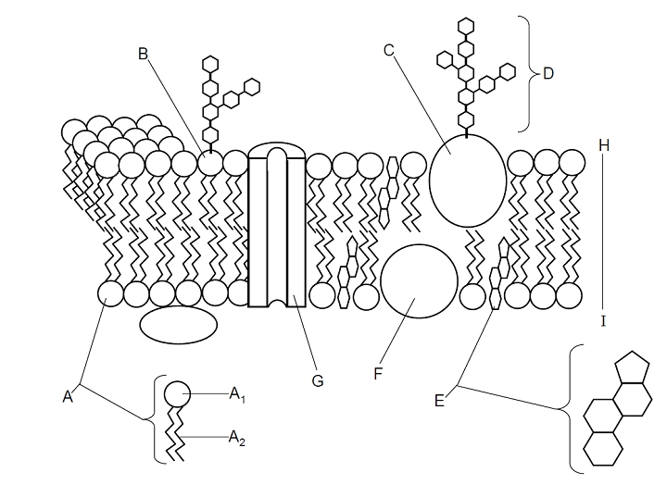

  - Name the molecules represented by the following structures.
(3 marks)
A₁ _____________________________________
A₂ _____________________________________
G _____________________________________
The graph below shows the rate of uptake of two solutes.
Solute A

Solute B

  - State which type of transport is represented by each solute and give an example of a material that moves by this method. (4 marks)

    - Solute A

_____________________________________________________________________________________________________________________________________________________________________________________________
    - Solute B

_____________________________________________________________________________________________________________________________________________________________________________________________

  - Describe the possible differences in the physical and/or chemical nature of Solute A and Solute B in relation to their movement across the cell membrane. (4 marks)

__________________________________________________________________________________________________________________________________________________________________________________________________________________________________________________________________________________________________________________________________________________________________________________________________________________
Question 32 (17 marks)

The respiratory system allows for the exchange of gases between the internal and external environments.

- Alveoli increase the surface area of the lungs to allow for diffusion. Name two other structural features of the lungs that assist in diffusion. (2 marks)

_________________________________________________________________________________________________________________________________________________________________________________________________________
___________________________________________________________________
Whilst exercising it is important the body receives adequate amounts of oxygen, otherwise fatigue may occur.

- Briefly explain the mechanics of breathing that allow the lungs to fill with air during exercise. (3 marks)
____________________________________________________________________________________________________________________________________________________________________________________________________________________________________________________________________________

- Explain the process of oxygen and carbon dioxide diffusion between the alveolus and capillaries in the lung of a person at rest. (4 marks)

__________________________________________________________________________________________________________________________________________________________________________________________________________________________________________________________________________________________________________________________________________________________________________________________________________________

Aerobic respiration is a metabolic process that occurs in many small steps controlled by specific enzymes.

- In aerobic respiration, how many ATP molecules are produced from one molecule of glucose. (1 mark)

__________________

- State the location/s that aerobic respiration occurs in. (2 marks)

______________________________________________________________________________________________________________________________________
- Many enzymes are involved in the different steps of aerobic respiration. Explain the specificity of enzymes to their substrates.
(3 marks)
____________________________________________________________________________________________________________________________________________________________________________________________________________________________________________________________________________
- Name two other factors that influence enzymes activity (2 marks)

____________________________________________________________________________________________________________________________________________________________________________________________________________________________________________________________________________

Question 33 (18 marks)

An accident occurred in which a man severed a main artery in his leg and was taken to hospital.

- Describe two structural differences between a vein and an artery. (2 marks)

____________________________________________________________________________________________________________________________________________________________________________________________________________________________________________________________________________

Once cut, the body’s external defence systems are open to micro-organisms. As micro-organisms may cause disease, these must be destroyed and removed.

- State the name of the cells specifically responsible for the destruction and removal of microorganisms. (1 mark)

___________________________________________________________________
- Explain why lymph nodes of the immediate areas surrounding the cut may swell and feel tender and sore. (2 marks)

____________________________________________________________________________________________________________________________________________________________________________________________________________________________________________________________________________

This question refers to the diagram shown below.
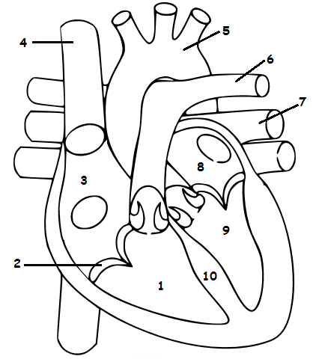

- Identify the above labelled structures:

1.
2.
7.
8
9
10.
(6 marks)

- What are the functions of structures 2, 5 and 6?

2. ___________________________________________________________________
5. ___________________________________________________________________
6. ___________________________________________________________________
(3 marks)

- Label all the veins and arteries on the diagram on page 15, with a “V” and an “Ar” respectively.
(2 marks)

- How does the heart muscle receive nutrients and remove metabolic wastes?

__________________________________________________________________ (2 marks)

Question 34 (20 marks)

Once ingested, food passes through the alimentary canal and is digested.

- Explain how the structure of the ileum, the third section of the small intestine, is well adapted to absorb nutrients. (4 marks)

__________________________________________________________________________________________________________________________________________________________________________________________________________________________________________________________________________________________________________________________________________________________________________________________________________________

Once absorbed, these nutrients are further broken down within the body.

- State the name given to the breakdown of proteins. (1 mark)

___________________________________________________________________

Proteins, and their substrates, can be removed from the body via the kidney.
Not all wastes are removed from the body in this way.

Study the diagram below and answer the questions that follow.

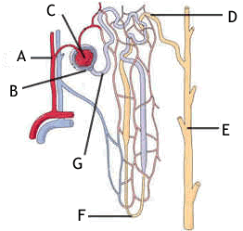

- Provide labels for structures:

A __________________________
B __________________________
C__________________________

E __________________________

F __________________________
(5 marks)

- Briefly explain how the afferent arteriole and efferent arteriole assist Structure C to carry out its function.
___________________________________________________________________________________________________________________________________________________________________________________________________________________________
(2 marks)

Water is reabsorbed via the cells that line the whole length of the nephron. The method of transport used to absorb the water in the proximal convoluted tubule (PCT) and Loop of Henle is different to the method used in the distal convoluted tubule (DCT) and collecting duct (CD).

- State which of the four tissue types the cells that regulate water reabsorption could be classified into.
_________________________________________________________________________________________________________________________________________
(1 mark)
- Explain how water molecules move from the PCT and Loop of Henle into the blood stream.
________________________________________________________________________________________________________________________________________________________________________________________________________________________________________________________________________________________
(3 marks)
- Name and describe how most of the water moves from the DCT and CD into the bloodstream.
__________________________________________________________________________________________________________________________________________________________________________________________________________________
(2 marks)
h) Describe the difference between elimination and excretion of wastes. (2 marks)

____________________________________________________________________________________________________________________________________________________________________________________________________________________________________________________________________________

Question 35 (20 marks)

Hydrogen peroxide (H₂O₂) is an unstable compound, decomposing to water and oxygen. Under normal conditions, the decomposition occurs very slowly. When yeast, which contains the enzyme catalase, is added, the reaction occurs faster. The table below shows the data collected during the experiment.

 | Volume of Gas Collected (cm³)
Temperature (ᵒC) | Trial 1 | Trial 2 | Trial 3 | Average
20 | 8 | 8 | 8
30 | 38 | 41 | 37
40 | 49 | 54 | 57
50 | 35 | 31 | 34
60 | 12 | 11 | 12

- Calculate the average volume of gas collected for each temperature. (5 marks)

- State why multiple trials of the experiment are undertaken. (1 mark)

___________________________________________________________________
___________________________________________________________________

- Identify the following variables:

  - Independent variable (1 mark)

______________________________________________________________

  - Dependent variable (1 mark)

______________________________________________________________

  - Two controlled variables (2 marks)

______________________________________________________________
______________________________________________________________
- On the grid paper provided, construct a graph that can be used to represent the data.
(5 marks)

If you wish to make a second attempt at this graph, extra grid paper can be found at the end of the examination booklet. Ensure you indicate this clearly.

- State the optimal temperature for the activity of catalase. (1 mark)

______________________________________________________________

- Describe the evidence that suggests that (e) is the optimum temperature for catalase activity. (2 marks)
___________________________________________________________________
___________________________________________________________________
___________________________________________________________________

- Describe what occurs to catalase after the optimum temperature is reached.
(2 marks)
___________________________________________________________________
___________________________________________________________________
___________________________________________________________________
___________________________________________________________________

Question 36 (14 marks)

The various tissues of the human body can be categorised into four basic tissue types. In the table below, identify the tissue type and state the function of the tissue. (6 marks)
(a)
 | Tissue Type | Function
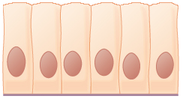

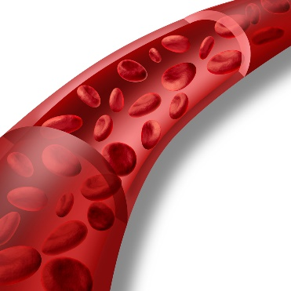

The following hypothetical cells are cuboidal in shape, with the length, breadth and heights as indicated.
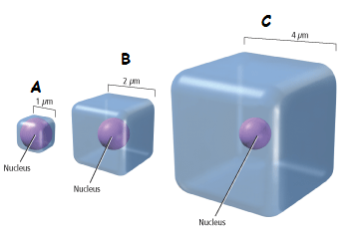
- Which of the cells in the diagram above (A, B or C) would have the smallest surface area to volume ratio?

______________________________________________________________________
- mark)
- Which of the cells in the diagram above (A, B or C) would supply its organelles with the substances they require most efficiently? Explain your reasoning.
________________________________________________________________________________________________________________________________________________________________________________________________________________________
________________________________________________________________________________________________________________________________________________
________________________________________________________________________________________________________________________________________________
- marks)
(d)Name two (2) inputs and two (2) outputs of typical cells.

Inputs ______________________________________________________________

Outputs ____________________________________________________________
(4 marks)
End of Section Two

Section Three: Extended answer 20% (40 Marks)

This section contains two (2) questions. You must answer one (1) question. Make sure you clearly indicate which question you are answering and write your answer in the space provided.
Spare pages are included at the end of this booklet. They can be used for planning your responses and/or as additional space if required to continue an answer.
  - Planning: If you use the spare pages for planning, indicate this clearly at the top of the page.
  - Continuing an answer: If you need to use more space to continue an answer, indicate in the original answer space where the answer is continued, i.e. give the page number. Write the number of the question(s) that you are continuing to answer at the top of the additional space page.
Responses could include clearly labelled diagrams with explanatory notes; lists of points with linking sentences; clearly labelled tables and graphs; and annotated flow diagrams with introductory notes.
Suggested working time: 20 minutes.

Question 37 (40 marks)
Every day we eat food and our bodies chemically breakdown these large molecules into smaller ones with the help of enzymes located in the alimentary canal.
- Describe how the mouth, stomach and small intestine allows for the processes of mechanical and chemical digestion to occur. (30 marks)

Once broken down, the nutrient materials are absorbed through the membranes of the cells lining the intestine.
- Compare and contrast facilitated diffusion and active transport. (10 marks)

Or
Question 38 (40 marks)
- Draw and label a capillary bed showing the following:
- Capillaries
- Venule
- Arteriole
- Lymph vessels.
Explain how nutrients and wastes are exchanged between capillaries and surrounding tissues.
(16 marks)
- For efficient metabolism, cells require nutrients such as carbohydrates, proteins and lipids. Describe the structure and function of these three nutrients. (24 marks)

End of questions

Question number: ________________
__________________________________________________________________________________________________________________________________________________
_________________________________________________________________________
_________________________________________________________________________
_________________________________________________________________________
_________________________________________________________________________
__________________________________________________________________________________________________________________________________________________
_________________________________________________________________________
_________________________________________________________________________
_________________________________________________________________________
_________________________________________________________________________
__________________________________________________________________________________________________________________________________________________
_________________________________________________________________________
_________________________________________________________________________
_________________________________________________________________________
_________________________________________________________________________
__________________________________________________________________________________________________________________________________________________
_________________________________________________________________________
_________________________________________________________________________
_________________________________________________________________________
_________________________________________________________________________
__________________________________________________________________________________________________________________________________________________
_________________________________________________________________________
Question number: ________________
__________________________________________________________________________________________________________________________________________________
_________________________________________________________________________
_________________________________________________________________________
_________________________________________________________________________
_________________________________________________________________________
__________________________________________________________________________________________________________________________________________________
_________________________________________________________________________
_________________________________________________________________________
_________________________________________________________________________
_________________________________________________________________________
__________________________________________________________________________________________________________________________________________________
_________________________________________________________________________
_________________________________________________________________________
_________________________________________________________________________
_________________________________________________________________________
__________________________________________________________________________________________________________________________________________________
_________________________________________________________________________
_________________________________________________________________________
_________________________________________________________________________
_________________________________________________________________________
__________________________________________________________________________________________________________________________________________________
_________________________________________________________________________
Question number: ________________
__________________________________________________________________________________________________________________________________________________
_________________________________________________________________________
_________________________________________________________________________
_________________________________________________________________________
_________________________________________________________________________
__________________________________________________________________________________________________________________________________________________
_________________________________________________________________________
_________________________________________________________________________
_________________________________________________________________________
_________________________________________________________________________
__________________________________________________________________________________________________________________________________________________
_________________________________________________________________________
_________________________________________________________________________
_________________________________________________________________________
_________________________________________________________________________
__________________________________________________________________________________________________________________________________________________
_________________________________________________________________________
_________________________________________________________________________
_________________________________________________________________________
_________________________________________________________________________
__________________________________________________________________________________________________________________________________________________
_________________________________________________________________________
Question number: ________________
__________________________________________________________________________________________________________________________________________________
_________________________________________________________________________
_________________________________________________________________________
_________________________________________________________________________
_________________________________________________________________________
__________________________________________________________________________________________________________________________________________________
_________________________________________________________________________
_________________________________________________________________________
_________________________________________________________________________
_________________________________________________________________________
__________________________________________________________________________________________________________________________________________________
_________________________________________________________________________
_________________________________________________________________________
_________________________________________________________________________
_________________________________________________________________________
__________________________________________________________________________________________________________________________________________________
_________________________________________________________________________
_________________________________________________________________________
_________________________________________________________________________
_________________________________________________________________________
__________________________________________________________________________________________________________________________________________________
_________________________________________________________________________
Question number: ________________
__________________________________________________________________________________________________________________________________________________
_________________________________________________________________________
_________________________________________________________________________
_________________________________________________________________________
_________________________________________________________________________
__________________________________________________________________________________________________________________________________________________
_________________________________________________________________________
_________________________________________________________________________
_________________________________________________________________________
_________________________________________________________________________
__________________________________________________________________________________________________________________________________________________
_________________________________________________________________________
_________________________________________________________________________
_________________________________________________________________________
_________________________________________________________________________
__________________________________________________________________________________________________________________________________________________
_________________________________________________________________________
_________________________________________________________________________
_________________________________________________________________________
_________________________________________________________________________
__________________________________________________________________________________________________________________________________________________
_________________________________________________________________________
Spare Grid

